Improving typhoon forecast with uncertainty quantification

Mengwei Li, Qingyun Duan, Zhenhua Di

College of Global Change and Earth System Science, Beijing Normal University

Correspondence to: limengwei@bnu.edu.com.cn

## Abstract

For decades, severe weather systems typhoon have caused [uncountable](http://dict.youdao.com/w/uncountable/" \l "keyfrom=E2Ctranslation) loss on casualties and properties in hitting areas worldwide, especially for concentrated urbanized countries like China. However, predicting typhoon considerably suffers from uncertainties including model physics and initial condition. To iron out such adverseness, in our experiment, we performed a whole set of Uncertainty Quantification (UQ) procedure including scoping out parameter, sampling, sensitivity analysis and parameter optimization to quest for a better accuracy in model performance. Further, we transfer this optimum to several other analogous typhoon events to validate its effectiveness and robustness.

The result shows that for most cases, the model outperforms than default in many aspects including precipitation and typhoon intensity. Our UQ solution improving typhoon forecast has demonstrated its effect and has provided researchers a promising way optimizing large complex model. Moreover, it’s also a good news for operational typhoon forecast center since this research has followed suit in terms of model settings by [China Meteorological Administration](http://dict.youdao.com/w/China%20Meteorological%20Administration/" \l "keyfrom=E2Ctranslation) (CMA), including model warm up, physical scheme selection and other necessary model settings, which could make it easier adapt to present practice.

## Introduction

Every year, many places in the world suffer from nature's most deadly power, storm. Such catastrophic weather events are probably the most devastating disasters humankind ever faced. Typhoon outweighed other disasters like earthquakes, volcanic eruptions in terms of frequency and often induce severe secondary disasters like storm surges and floods[1]. When landfall takes place in urban area it would cause the most devastating damage. They are able to topple trees, down power lines, and killing anyone in its path. Often they leave in their wake a trail of injury, death, loss of livestock, property damage and economic loss. China is ranked one of the most severe typhoon affected countries due to its long and rich coastlines near the Southeast Asia region, where there are over 10,000 casualties and US$2500 million economic losses annually on average[2]. According to statistics at CMA, merely the number of landfilling can reaches 8 to 10 times according to statistics each year in China. The impact is self-evident.

Though such extreme event is devastating, it is in one of the few disasters that give people lead time, thus we can plan things until the storm really hits -- gather supplies, suspend civil liberties or evacuation if necessary. With the state of the art technology, scientists and experts can nowadays speculate the date and time even the place where storm will strike with the help of numerical model like WRF. But what to do next? Should residents all evacuated from their homeland and later proved to be unnecessary? Or should we keep going out for shopping then ended up blowing away by brutal wind? Should water departments vacuum up their reservoirs to be prepared for a coming pouring rain? An accurate prediction of typhoon intensity and other attributes is the only key to these problems. If numerical models always work fine, theoretically, we can always be set of pertinent preparedness ahead, in areas that are potentially threatened.

And that is why the main purpose of this essay focuses on the second issue, forecasting, trying our way through to find an effective way better utilizing complex numerical forecasting typhoon. The problem is however, numerical model keeps sufferingnjop from three main flaws that compromise its forecast: 1) model error; 2) data error and 3) parameter error summarized by Duan in 2006[3], which respectively refers to 1) model structure insufficiency; 2) initial/boundary conditions inaccuracy and 3) model parameters uncertainty. When it comes to large physical models which could takes hours for a single forward run, these defects are increasingly fierce, making the improvement in numerical typhoon forecasting represents one of the greatest challenges in numerical weather prediction (NWP)[4].

In fact, researchers have tried hard to find a way to do better forecast over typhoon. Preliminary, the pursuits are around to eliminate three above mentioned compromising factors:

First, to improve the structure of model forecasting typhoon, efforts have been made by Emanuel in 2003[5], Donelan et al. and Moon[6] in 2004 as they all attempted to refine the physical process of model by exploring the sea surface water heat flux mechanism that impact local Atmospheric Motion. Davis et al.[7] have studied local air-sea interaction based on the impacts of ocean sea surface feedback processes for TC development, Ma and Tan[8] in 2009 modified a new convective parameterization scheme for modellers to choose, yet Chen et al. in 2007[9] have focused on model resolution setup affecting model performance. Second, to obtain better initial condition, various initialization methods have been proposed. Ueno in 1989[10], Davis and Nam[?] in 2001 all have proved that the use of analytic empirical functions to generate synthetic or bogus( bogus is a mathematical model simulating intensity-vortex system) vortex for surface pressure and wind to replace the vortex in the analysis can warm up the initial model condition. Scientists like George, Jeffries in 1994[11] and others in later year[12][13] has employed synthetic data assimilation (known as BDA) approach which uses variational data assimilation with synthetic observations of a TC vortex that closely matches the observed TC intensity and structure. Kurihara et al. in 1993[14] proposed an axisymmetric vortex generation initialization method, then similar method was used in the U.S. Navy regional coupled model for TC prediction by Hendricks et al. in 2011[15] When modeling a typhoon, it is of great significance having such warm up process to the model. The third is to refine model parameter specifications during typhoon forecast. Former research paid little attention to this field. There are studies of tuning parameters in runoff models like sacramento model[16], and there are also studies that tries to optimize parameter over inland rainfall[17], but relevant research is rare as for typhoon forecast. Yet it is still neccessary for us to look deeper into this issue as “an unmerited or erroneous parameter specification, especially for dominate ones would have significant influence on model performance”[18].

For three flaws mentioned above, in this study, we sought to address these issues, especially the third: we employee WRF version 3.7 meeting ends of favorable model structure and model robustness to deal with first flaw; a productive WRF module called Dynamical Initialization (DI) to spin up model condition dealing with the second; and a whole set of uncertainty quantification (UQ) procedure for parameter calibration with the last. We expect a better typhoon prediction in terms of many aspect we may consider in practice: intensity, which could be measured by pressure and wind speed, precipitation, which could be measure by TS or accumulated amount.

This paper is arranged as follows: Section 1 above gave out an introduction of typhoon forecast using numerical model, its background, state of art and existing problem. Section 2 below will depict relevant methodology we use optimizing such problem. Section 3 is a case study of typhoon Rumbia (NO.1306) with detailed information about model settings, warm up and specific UQ implementation. Section 4 shows the result of target case optimization and we then after authenticate the its effectiveness by transfer it to other four validation cases. At last, section 5 there are summary of conclusions and further discussion.

## Methodology: Uncertainty Quantification (UQ)

To reduce the impact of parameter specification ambiguity, we undertook a whole set of uncertainty quantification (UQ) procedure. This procedure contains key steps used in many fields of engineering and geophysics, sensitivity analysis and optimization, to assess and predict the likelihood of various outcomes[19]. It is an expected way to quantitatively characterize and reduce uncertainties that show up in experiments. Particularly for computer models, this uncertainty attribute to parameter uncertainty. However, parameter specification is complicated by the fact that today’s geophysical models consider an increasing number of physical processes (water/energy cycles, biogeochemical processes etc.) that induce loads of parameters and dramatically increase the dimension of problem. Without a series of systematic approach such problem can be too expensive to solve for computing resources.

Rigorously perform a whole set of UQ from scratch can be of great workload, including (Fig1 below): 1)characterize the uncertainty sources for a given problem, 2)set up the experimental design to implement proper sampling (which includes identifying their range and distributions), 3)screen out sensitive parameters when dimension of problem is high[20], 4)construct surrogate/meta model as substitute if forward model is time consuming[21], 5)implement proper optimization algorithm to gain desired outcome and test its accountability etc. Fortunately, making use of our previous developed software “UQ-PyL” specially designed for all kinds of model uncertainty analysis to perform such footages is quite easy.

HERE FIG ONE

Above Fig1 also shows our sequence undertaking UQ in this study.

Specifically, our objective in step1 ‘problem definition’ is to improve typhoon prediction by WRF. In step2, as there are seven scheme that mainly controls the action of model, from which we scope out 23 time invariant adjustable parameters influencing on output and grant them a disturbance band for later calibration. This procedure primarily depends on general understanding of the model and reviewing previous studies[22], as well as consulting experts or founder of certain module. Further details their sources, physical meanings, ranges are listed below in Table1.

HERE TABLE ONE

For step3, there are few more child steps within Design of Experiment (DoE). First is sampling. We first adopt quansi-monte-carlo (QMC) method sampling over these parameters (which ensures a good space-filling capability and recommended by former studies). We took total sampling time of 250, as recommended in previous study of JD.Li, which suggests that for the dimension of our problem, sampling time about 10 times the dimension should be able to balance efficiency of computation and effectiveness of grasp of model dynamics[23]. Note that besides these 23 parameters, all other types of data like boundary forcing, assimilation data, or any other internal variables (number of grid points for example) we fed into model are consistent---they are not allowed to vary thus they cannot contribute to any variation in the output.

Also in step3 above, we quantified their sensitivity. Sensitivity analysis (SA) defines of how uncertainties in model output is proportioned the input variation. To achieve this, we proposed a few objective functions, all their expressions, physical meanings and purposes, are listed in below Table2. Additionally, the outcome of their sensitivity results are base on comprehensive result of multiple analysis methods, including multivariate adaptive regression spline (MARS), sum of tree (SOT), delta-test (DT) and surrogate-based Sobol. That is to say, for each given objective, we conducted sensitivity based on different methods. Thus, the cumulative significance S of parameters i can be computed as:

 (1)

where C_mn is the sensitivity vector of 23 parameter evaluated by method m considering objective j, f_N0-1 performs 0-1 normalization over methods where 1 represent most sensitive, 0 to least sensitive. The cumulative significance denoted as S_i is computed as average over number of objectives N times number of SA methods M.

HERE TABLE TWO

Next in step4, as for WRF model, since a single model forward will take hours of CPU, it will be very expensive to do all computation on original model for optimization algorithm , thus we build surrogate (or meta) model based on Gaussian Process Regression (GPR). GPR is one of machine learning methods. It is based on statistical learning theory and Bayesian theory, and it’s perfectly suit for this high-dimensional yet small-sampling problems with nonlinear regression[25].

In final step5, based on several top sensitive parameters previously screened out, we improve search speed during optimization by adaptive surrogates modeling optimization (ASMO) method. Briefly, in ASMO optimization algorithm, it uses a surrogate model per epoch which is constructed by adaptive sampling to represent the input-output response of the original simulation model[26]. In our experiment, we built up initial surrogates with 200 sample run on dominant parameters selected. At each epoch, there will be a newly sampled point (or points), and corresponding value from simulation to refine response surface to make it more accurate.

The chose of objective function (lose/energy function) is also very important. Note that the objectives we use here could differ from what we used in SA processes. To ensure our optimization result more tangible for practical use, our final objective function is composed of several widely concerning criterion evaluating typhoon forecast skill. Specifically, we chose four criterion: 1) maximum wind speed MAE, 2) center pressure MAE, 3) rainfall Thread Score (TS, in practical use we use negative TS to have its optimize direction coherent with other criterion’s) and 4) 6-hourly precipitation amount error. In order to transform multi-objective problem into single-objective problem, four criterion are equally weighted after normalization before they serve as our final objective function. Assumes that f_z(v_s) performs Z-score function to vector v_s where v_s is evaluated value over criterion s, and number of criterion denoted as N. Then final objective y can be given as:

 (2)

## Experimental Design

### Model settings

Late June and early July in 2013, typhoon Rumbia comes ashore in China. She wiped the coast of Guangdong striking a serious punch, and crippled entire communities. Rumbia continued strengthening over open water, and reached its peak intensity. Heavy rain and high winds rattled the sky and kicked up mountainous wave at ocean. Flood water surged over the levees and gulfed the city. Though no death toll reported, merely across Guangdong Zhanjiang 152 million people were affected, of which 5.5 million were temporarily displaced or evacuated the hurricane zone. About 183,000 hectares of crops were destroyed, with total economic losses amounting to 1.081 billion YUAN(US$176.5 million)[2].

As a matter of fact, statistics tell that about 80% of typhoon landfall take place during this midsummer season period of year, with over half of them (56.6%) are centered on Guangzhou and Hainan province. Thus our research will mainly focus over this area this time of the year. The case of Rumbia will serve as target case in our study. The following Table3 elaborates how in our experiment WRF model is configured.

HERE TABLE THREE

It’s worth mentioning that in order to have a warm-up (Dynamical Initialization) module combined with our later experiment (detailed below), we intentionally run model with vortex-following mode for previous 6-hour window to spin up model, forging a preferable initial state, and switch to fixed domain setting for following three-day prediction followed concerning spatial resolution. Such act guarantees the realization of vortex spin up at starting hours yet still provide high resolution when forecasting and brings an order magnitude of speed up in terms of computation hours. Additionally, concerning the potential imperfection resides in precipitant data off-shored, we could employed a mask over no-land area, so to the corresponding model output data. The wind speed and pressure data are crawled from web of Zhejiang water conservancy information management center, and there are not masked overseas in order to grasp the intact typhoon structure.

### 2. Warm up

In this article, we employeed a recent-year’s Dynamical Initialization (DI) scheme firstly purposed in 2011 by Nguyen[27], further improved and modified by Cha and Wang in 2012 to fine tune model condition[28]. China Meteorological Administration (CMA) has implement this typhoon assimilation method into its real-time TC forecasting system. Briefly, this new DI scheme consists of four procedures:1) separation of a TC vortex, 2) repeated cycle runs for TC vortex spinup, 3) spectral nudging to reduce bias in large-scale fields in the cycle runs, and 4) relocation of the spun up TC vortex to the observed position.

According to Dong-Hyun Cha and Yuqing Wang, this module improves the initial conditions meanwhile gains positive effects on both track and intensity to forecast typhoons. The other reason we determined to choose this scheme is to follow suit of real-time typhoon forecasting operational system by China Meteorological Administration (CMA).

Additionally, the choice of parameterization schemes completely follows the operational setup by China Meteorological Administration in the aim of a seamless research-practice use.

### 3. UQ integrated solution

To integrate the uncertainty quantification procedure with warm-up in our experiment, we designed a road map with two cycles, with outer loop implementing UQ and inner loop for warm-up each time. Following flowchart in Fig2 is proposed:

HERE FIG TWO

As illuminated above in Fig2, a usual WRF prediction run is expanded with two cycles that jointly interact. Specifically, with vortex following mode, we first run inner DI cycle letting the model start 6-hour beforehand as window time(denoted as “WRF spin-up run” in fig) and to judge whether its simulation is accurate enough for further prediction by comparing “features” (refers to typhoon vortex location, pressure, wind speed etc.) with observations given in external files. If these features are poorly consistent, this process will keep cycling over time, gradually fill the gap of between model and observation until this mismatch is within an acceptable range.

Then, this ‘warmed-up’ field is in lieu of the old poor one, and our model is switched to fixed domain mode. The UQ cycle started to take over for following 3-day forecast. This time system cycles through different parameter sets: each time a prediction is done, all 23 parameters chosen from WRF schemes will be re-sampled and renewed automatically in model code. The downstream steps after are as depicted earlier in methodology part.

The combination of DI and UQ architecture works like a “double insurance” to model simulation: Correct state at beginning, and restrain model behavior alongside.

## Results

To prepare a lower dimension optimization cutting down computation costs, we first committed sensitivity analysis to 23 parameters with 250 model run. As mentioned before, the sensitivity experiments were conducted on different proposed objectives (view in Table2) using different SA methods including including multivariate adaptive regression spline (MARS), sum of tree (SOT), delta-test (DT) and surrogate-based Sobol. Below Fig3 shows the result of parameters’ sensitivity over different objectives evaluated by bunch of SA methods each. Our proposed objectives are categorized into three types: rainfall related type (total precipitation amount, TS, rainfall MAE etc.), pressure related type (determination coefficient, MAE and RMSE) and wind-speed (Beaufort 10 scale wind radius, determination coefficient, MAE and RMSE) related type. The bottom row sums all importance together computing cumulative significance S as in detailed in (1).

HERE FIG THREE

Parameters’ sensitivity score in above fig are rearrange between range 0 and 1 each row, where 1 represents the most sensitive and 0 the least. Some common features are showed: 1)Despite the different kind objectives we use, some same parameter are always tend to be more sensitive than others. Like parameter No.3 (pd) No.4(pe) and No.5 (ph), their blocks are dyed deeper all the time, which makes them three ranked top sensitive when we consider all objective in last row. 2) Different type of objectives will also give different sensitivity evaluation score. Such as, parameter No.4 (pe) is very sensitive to wind speed and pressure but not that much to rainfall; parameter No.10 (dimax) is very sensitive to rainfall yet less sensitive to wind speed and pressure, etc. 3)Some parameters like No.2 (CZO), No.11 (peaut) and No.22 (DSATPSI) are seemed negligible to any results of concerned functions, thus if we are worrying about high-dimensional issue, they are the first ones that we could choose to get rid of. 4) The average importance ranking of top parameters is also noticeable in last row from text we tagged. Top eight parameters are: No.5 (Ph), No.4 (pe), No.3 (pd), No.9 (N0r), No.17 (pfac), No.8 (ice_stokes_fac), No.10 (dimax) and No.12 (CSSCA).

With following optimization, we consider mean score of all objectives computed as (1)(last row in above fig) to give out their final rank. In our experiment, we take threshold of 70% uncertainty contribution to do the screen out. Altogether 8 parameters are chosen: they are parameter number 5,4,3,9,17,8,10,12 (sorted from most sensitive).

ASMO optimization usually starts with a surrogate model to minimize its cost function. Employing above 8 parameters, we conduct 200 sample run as initial population to build this surrogate. Then from loop time 200, algorithm starts to search optimum. The value of objective function we use is Z-score normalized with four objective: 1)6-hourly precipitation amount error, 2)-TS, 3)center pressure error and 4)maximum speed error as depicted earlier in (2). Fig4 below shows real optimization process together with default value, which is also evaluated by (2) and colored red in dash. The coarser lower curve in blue stands for global minimum found at present.

HERE FIG FOUR

As portrayed above in Fig4, for first 200 loop, the algorithm walk randomly causing value of objective “zipzag” to optimize or worsen (below or above default red dash) the model. When it starts to search optimum, this value tend to go down indicating that there’s less error in model output, only with few times worsen the model. This pattern of model action implies the algorithm is functioning good. It shows that in loop time of 218 a new optimum point in reached with cost function value of -6.51. Yet we can say that this is not an easy task for another 30 loops later in loop 247 this value only improves 0.06 to -6.57 and never improve anymore for last 53 run. The optimization stopped at loop 300 with minimum cost function value -6.57 at loop 247. Note that this function value here is not necessarily our percentage of improvement, it’s only a overall objective value of our four concerned objectives in (1).

This optimum set of 8 dominant parameters are put up here in Fig5. This result shows that comparing to default set, besides parameter named ‘N0r’, ‘CSSCA’ and ‘Pfac’, parameters are all given a higher value. Wherein ‘Ph’ and ‘ice_stokes_fac’ are even over 2 and 1 times than default value. In contrast, parameters like ‘Pd’ , ‘N0r’ and ‘Dimax’ are only sightly tuned with couple of percentage points no more than 10%. Nevertheless it’s worth mentioning that although these parameters were only tuned a bit, it does not mean that the tuning of them is unnecessary. As a matter of fact, for parameters as sensitive as ‘pd’ only 1% variation of its value can end up with significant different in model results due to nonlinear and interactive effect in uncertainty propagation.

HERE FIG FIVE

Finally, we redo the forecast of typhoon Rumbia with all parameter set to optimal value provided by ASMO algorithm and record its model performance improvement, in below Table4. It shows that all objectives are noticeably improved, with maximum improvement on 6-hourly MAE of center pressure----from 6.95hpa of to 5.9hpa, reaching an improvement of 15.13%. The overall improvement for this case is 9.35%.

HERE TABLE FOUR

To visualize these improved results and have a clear sight of what’s going on in model output, we have plotted group of figures to reinforce our further understanding.

In following group of figures (Fig6), we tried to shown the improvements of wind speed and typhoon center pressure over whole case period (36 hours) as listed in Table4. First, variation of maximum wind speed by observation (blue), optimization (read) and default are illuminated on the left. We can see that the red curve after optimization is more closer observation curve except at hour 12, and 36 to 48 reducing MAE from 5.71m/s to 5.42m/s. Meanwhile, variation curve of typhoon center pressure on the right is more apparent of improvement: only at hour 42 and hour 66 not surmounting default, achieving 15.13% optimization from 6.95hpa to 5.9hpa MAE in average.

HERE FIG SIX

Enhancement of TS score trigger by optimization is exhibited below in Fig7. It should be mentioned that since rainfall TS is appraised based on a set of established criterion (e.g rainfall within range of 25mm~50mm a day will be ranked as moderate rain), we thus intentionally transform precipitation amount to their corresponding rank to visualize their enhancement of ranking forecast. Color green in figure means good, suggesting a rank approximating ‘real rank’ given by observation, yet color red suggests a degradation far from reality. What we see from figure below is that most of the colored areas are green, within which there are also darker green areas indicating a two-level enhancement, especially at south-west direction. The large green-red proportion implying that TS is substantially getting better reaching an improvement of 12.52%.

HERE FIG SEVEN

Next, to analyze improvements on precipitation amount, we have Fig8 below in which three-day’s observed precipitation data is plotted on the left comparing with optimized precipitation in the middle and the default on the right. The first thing we notice is that no matter for optimal or default, the model always have bias producing rainfall larger than physical truth along its track. Yet middle figure have demonstrate that this bias could have been correct to some extent by optimization, for we see wherein precipitation is apparently weakened comparing to the left one. In spite of this, it’s also obvious that we can’t rectify the manner of rainfall, which have caused the too much precipitation distribution in south-east direction of Hainan island, or too concentrate to its path.

HERE FIG EIGHT

## Validation

To authenticate the accountability of optimal parameter set, we put up several verification cases. All verification cases are from same period (August, 2013) of typhoon Rumbia: Jebi, Utor, Trami and Kong-rey. All model settings including driving data, observation data and model warm up are identical with what we have for typhoon Rumbia listed in Table3, except for simulation period and domain settings. Whereas this time, all parameters we fed into model are proposed by previous optimization result of typhoon Rumbia. The domain settings and other information of four are given in Table5. In last column ‘Remarks’, we have typhoons’ category recorded, wherein ‘TS/CATG1/CATG2’ stands for Tropical Storm/Category1/Category2 respectively. In order to mark off rainfall Thread Score (TS) and typhoon category Tropical Storm (TS), we denoted Tropical Storm as ‘cat-TS’ later in our passage. Note that our target case Rumbia belongs to cat-TS.

HERE TABLE FIVE

After running forecast on these four cases, following result are given to evaluate the effect of optimal transfer (Fig9). We present model performance by objective functions evaluated. For the sake of a convenient comparison, we also present therein previous Rumbia optimization result in Table4 first one left. From the result, we see that cases of Jebi, Utor and Kong-rey have all outperformed than default when forecasting its typhoon, with average improvements of 8.53%, 2.01% and 6.99% respectively. We are surprise to find that Jebi have most tangible improvement of 8.53% which is even comparable to what we have in target case 9.35%. We speculate that this is because Jebi case has the same typhoon category of cat-TS to our target case Rumbia. Such [conjecture](http://dict.youdao.com/w/conjecture/" \l "keyfrom=E2Ctranslation) can also be backed by Kong-rey case which also belongs to cat-TS and has gained 6.99% improvement in average, indicating that our optimum solution may have great potential generalizing over typhoon events with similar intensity. In contrast, for Utor and Trami of category CATG2 and CATG1, it’s much harder for model to perform very good---Utor forecast was only improved by 2.01%, yet unfortunately objectives of Trami have been sightly worsen.

HERE FIG NINE

## Conclusion

In our study, we implemented a whole set of uncertainty qualification (UQ) procedure sought to improve numerical typhoon forecast. By replacing the old parameter set with our optimized prime set, we gained a more satisfied result forecasting typhoon events. Only in one case, model performance is slightly undermined while others have all showed handsome improvement. If we factor in category difference, this result might be better. However, for errors that can’t be eradicated by parameter calibration due to model limitation, we can only count on future model structure improvement to fix them.

There several key findings: 1) Considering different SA methods, several dominant parameters that may exert great influence forecasting typhoon are: parameter No.5 (Ph), No.4 (pe), No.3 (pd), No.9 (N0r), No.17 (pfac), No.8 (ice_stokes_fac), No.10 (dimax) and No.12 (CSSCA), yet other 15 parameter also contribute to model output about 25%. 2) ASMO optimization method work out fine will with this kind of problem, proving itself a promising algorithm optimizing large complex numerical modes, yet it’s also possible that some other heuristic methods may also helps. 3) Generalizing specific best solution on one case to other different cases is possible, though optimal solution for other cases may not be exactly the same. 4) The effectiveness of this result may also depend on what types of event we’re forecasting. We may focus on future ensemble forecast involving all types of typhoon events to fix this issue.

An accurate prediction of typhoon will always be one of urgent needs for humankind. It’s crucial to our preparedness and evacuation, as well as ensuring a better use of its lead time. Such issue will always draw attention of current science.

This research work provides a reliable solution improving the effectiveness for typhoon forecast using large complex model WRF. At the same time, since we have followed suit in model settings with CMA’s typhoon real-time forecasting system, it could act as a valuable guidance for business departments to improve their forecast quality and have potential reducing loses of extreme typhoon events.

## References

[1*]Almanac article: Fact Monster.© 2000–2013 Sandbox Networks, Inc., publishing as Fact Monster.01 Nov. 2016 http://www.factmonster.com/ipka/A0775896.html

[2*]Recent studies on tropical cyclone land falling in China; Lei Xiaotu, Shanghai Typhoon Institute CMA, Shanghai, China

[3]Duan Q, Schaake J, Andréassian V, et al. Model Parameter Estimation Experiment (MOPEX): An overview of science strategy and major results from the second and third workshops[J]. Journal of Hydrology, 2006, 320(1–2):3-17.

[4]Chunchieh W U, Bender M A. Typhoon Forecast with the GFDL Hurricane Model: Forecast Skill and Comparison of Predictions using AVN and NOGAPS Global Analysis[J]. Journal of the Meteorological Society of Japan, 2000, 78(6):777-788.

[5]Emanuel K. A Similarity Hypothesis for Air-Sea Exchange at Extreme Wind Speeds.[J]. Journal of the Atmospheric Sciences, 2003, 60(11):1420-1428.

[6]Moon I J, Ginis I, Hara T. Effect of surface waves on Charnock coefficient under tropical cyclones[J]. Geophysical Research Letters, 2004, 31(20):379-398.

[7]Davis C, Wang W, Chen S S, et al. Prediction of Landfalling Hurricanes with the Advanced Hurricane WRF Model[J]. Monthly Weather Review, 2008, 136(6):1990-2005.

[8]Ma L M, Tan Z M. Improving the behavior of the cumulus parameterization for tropical cyclone prediction: Convection trigger[C]// 全国优秀青年气象科技工作者学术研讨会. 2010:190-211.

[9]Chen S S, Price J F, Zhao W, et al. The CBLAST-Hurricane Program and the Next-Generation Fully Coupled Atmosphere Wave Ocean Models for Hurricane Research and Prediction[J]. Bulletin of the American Meteorological Society, 2007, 88(3):311-317.

[10*]Ueno, M., 1989: Operational bogussing and numerical prediction of typhoon in JMA. JMA/NPD technical report, No. 28, 48 pp.

[11]Goerss J S, Jeffries R A. Assimilation of Synthetic Tropical Cyclone Observations into the Navy Operational Global Atmospheric Prediction System[J]. Weather & Forecasting, 1994, 9(4):557-576.

[12]Zou X, Xiao Q. Studies on the Initialization and Simulation of a Mature Hurricane Using a Variational Bogus Data Assimilation Scheme.[J]. Journal of the Atmospheric Sciences, 2010, 57(6):836-860.

[13]Davidson N E, Weber H C. The BMRC High-Resolution Tropical Cyclone Prediction System: TC-LAPS[J]. Monthly Weather Review, 2010, 128(5):1245.

[14]Kurihara Y, Bender M A, Ross R J. An Initialization Scheme of Hurricane Models by Vortex Specification[J]. Monthly Weather Review, 1993, 121(7):2030.

[15]Hendricks E A, Peng M S, Ge X, et al. Performance of a Dynamic Initialization Scheme in the Coupled Ocean-Atmosphere Mesoscale Prediction System for Tropical Cyclones (COAMPS-TC)[J]. Wea Forecasting, 2011, 26(5):650-663.

[16]Sorooshian S, Duan Q, Gupta V K. Calibration of rainfall‐runoff models: Application of global optimization to the Sacramento Soil Moisture Accounting Model[J]. Water Resources Research, 1993, 29(4):1185–1194.

[17]Gilmore M S, Straka J M, Rasmussen E N. Precipitation Uncertainty Due to Variations in Precipitation Particle Parameters within a Simple Microphysics Scheme[J]. Monthly Weather Review, 2004, 132(11):2610.

[18]Duan Q, Sorooshian S, Gupta V. Effective and efficient global optimization for conceptual rainfall‐runoff models[J]. Water Resources Research, 1992, 28(4):1015-1031.

[19]Wang C, Duan Q, Tong C H, et al. A GUI platform for uncertainty quantification of complex dynamical models[J]. Environmental Modelling & Software, 2016, 76(C):1-12.

[20]Gong W, Duan Q, Li J, et al. Multi-objective parameter optimization of common land model using adaptive surrogate modeling[J]. Hydrology & Earth System Sciences Discussions, 2014, 11(5):2409-2425.

[21]Leary S J, Bhaskar A, Keane A J. A Derivative Based Surrogate Model for Approximating and Optimizing the Output of an Expensive Computer Simulation[J]. Journal of Global Optimization, 2004, 30(1):39-58.

[22]Di Z, Duan Q, Quan J P. Assessing WRF Model Parameter Sensitivity and Optimization: A Case Study with 5-day Summer Precipitation Forecasting in the Greater Beijing Area[C]// EGU General Assembly Conference. EGU General Assembly Conference Abstracts, 2015.

[23]Li J D, Duan Q Y, Gong W, et al. Assessing parameter importance of the Common Land Model based on qualitative and quantitative sensitivity analysis[J]. Hydrology & Earth System Sciences Discussions, 2013, 17(8):3279-3293.

[24]Wernli H, Paulat M, Hagen M, et al. SAL—A Novel Quality Measure for the Verification of Quantitative Precipitation Forecasts[J]. Monthly Weather Review, 2008, 136(11):4470-4487.

[25]Ounpraseuth S T. Gaussian Processes for Machine Learning[J]. International Journal of Neural Systems, 2004, 14(2):69.

[26]Wang C, Duan Q, Gong W, et al. An evaluation of adaptive surrogate modeling based optimization with two benchmark problems[J]. Environmental Modelling & Software, 2014, 60(76):167-179.

[27]Van Nguyen H, Chen Y L. High-resolution initialization and simulations of Typhoon Morakot (2009)[J]. Monthly Weather Review, 2011, 139(5): 1463-1491.

[28]Cha D H, Wang Y. A dynamical initialization scheme for real-time forecasts of tropical cyclones using the WRF model[J]. Monthly Weather Review, 2013, 141(3): 964-986.

[ap.1]Wang H, Wang Y, Xu H. Improving simulation of a tropical cyclone using dynamical initialization and large-scale spectral nudging: A case study of Typhoon Megi (2010)[J]. 气象学报英文版, 2013, 27(4):455-475.

[29]Shen, Y, P. Zhao, Y. Pan and J. J. Yu, A high spatiotemporal gauge-satellite merged precipitation analysis over China. Journal of Geophysical Research, 2014, 119, 3063-3075, doi: 10.1002/2013JD020686.

[30]Xie, P. P., and A. Y. Xiong, A conceptual model for constructing high-resolution gauge-satellite merged precipitation analyses, Journal of Geophysical Research, 2011,116, doi: 10.1029/ 2011JD016118.

## Appendix:

###### Dynamical Initialization scheme

Model warm up like data assimilation is worthwhile for numerical weather prediction (NWP) models to gain more accuracy in initial conditions. Different method may end up with slightly different model state. Considering to be accordant with CMA operational settings to be set for possible future operational guiding significance, we use Dynamical Initialization (DI) module approved by CMA which has also been proved effective. A rough view of DI scheme is portrayed below in Fig9. It consists of four main procedures in model pre-run period: 1) separation of a typhoon vortex; 2) repeated cycle runs for typhoon vortex spin up; 3) spectral nudging to reduce bias in large-scale fields in the cycle runs, and 4) relocation of the spun up typhoon vortex to the observed position.

HERE FIG TEN

According to [29], in step 1, Kurihara vortex separation method is proposed in DI scheme to enhance the vortex component, which is the main purpose in spinning up. Because the vortex component in real typhoon is not necessarily circular, while minimizing the removal of important non-hurricane features, it uses a filtering method to obtain the vortex component. In step 2, cycle runs are repeated by WRF model runs conducting a 6-h window before forecast time. Literally this cycle process, embedded the generated axisymmetric vortex component from last run to the next run until simulation approximate to observation. In step 3, by the act of spectral nudging, we try to eliminate possible nontrivial error in the environmental field at initial forecast time against the model driving data. Finally in step 4, DI scheme utilizes a relocation method that is similar to Hsiao et al. (2010), to avoid a non-negligible position error in its center.

Other than fill the gap between observation and prediction, during spin up spectral nudging (SN) is used to keep the environmental information close to the observations as well as to retain motions with wavelengths longer than 1000km, this allows the typhoon vortex to better adapt to the environment and to achieve the dynamical balance sufficiently. At the same time relocation will happen if the vortex position is not close enough to where it has actually been monitored as described in [ap. 1].

Table1. The range, and interpretation of parameters selected

|  |  |  |  |  |  |
| --- | --- | --- | --- | --- | --- |
| ***Index*** | ***Scheme (Source file)*** | ***Parameter*** | ***Default*** | ***Range*** | ***Description*** |
| ***No.1*** | *Surface layer*  *(module_sf_sfclay.F)* | *Xka* | *2.4e-5* | *[1.2e-5 5e-5]* | *The parameter for heat/moisture exchange coefficient(s m-2)* |
| ***No.2*** | *Czo* | *0.0185* | *[0.01 0.037]* | *The coefficient for converting wind speed to roughness length over water* |
| ***No.3*** | *Cumulus*  *(module_cu_kfeta.F)* | *Pd* | *None* | *[-1 1]* | *The multiplier for downdraft mass flux rate* |
| ***No.4*** | *Pe* | *None* | *[-1 1]* | *The multiplier for entrainment mass flux rate* |
| ***No.5*** | *Ph* | *150* | *[50 350]* | *Starting height of downdraft above USL(hPa)* |
| ***No.6*** | *TIMEC* | *2400* | *[1800 3600]* | *Average consumption time of CAPE(s)* |
| ***No.7*** | *TKEMAX* | *5* | *[3 12]* | *The maximum turbulent kinetic energy (TKE) value*  *in sub-cloud layer(m2 s-2)* |
| ***No.8*** | *Microphysics*  *(module_mp_wsm6.F)* | *ice_stokes_fac* | *14900* | *[8000 30000]* | *Scaling factor applied to ice fall velocity(s-1)* |
| ***No.9*** | *n0r* | *8e+6* | *[5e+6 1.2e+7]* | *Intercept parameter of rain(m-4)* |
| ***No.10*** | *dimax* | *5e-4* | *[3e-4 8e-4]* | *The limited maximum value for the cloud-ice diameter(m)* |
| ***No.11*** | *peaut* | *0.55* | *[0.35 0.85]* | *Collection efficiency from cloud to rain auto conversion* |
| ***No.12*** | *Short Wave Radiation*  *(module_ra_sw.F)* | *cssca* | *1e-5* | *[5e-6 2e-5]* | *Scattering tuning parameter (m2 kg-1)* |
| ***No.13*** | *beta_P* | *0.4* | *[0.2 0.8]* | *Multiplier for clear-sky aerosol scattering effect* |
| ***No.14*** | *Longwave*  *(module_ra_rrtm.F)* | *secang* | *1.66* | *[1.55 1.75]* | *Diffusivity angle for cloud optical depth computation* |
| ***No.15*** | *Planetary Boundary Layer*  *(module_bl_ysu.F)* | *brcr_sbrob* | *0.3* | *[0.15 0.6]* | *Critical Richardson number for boundary layer of water* |
| ***No.16*** | *brcr_sb* | *0.25* | *[0.125 0.5]* | *Critical Richardson number for boundary layer of land* |
| ***No.17*** | *pfac* | *2* | *[1 3]* | *Profile shape exponent for calculating the*  *momentum diffusivity coefficient* |
| ***No.18*** | *bfac* | *6.8* | *[3.4 13.6]* | *Coefficient for prandtl number at the top of the surface layer* |
| ***No.19*** | *Sm* | *15.9* | *[12 20]* | *Counter gradient proportional coefficient of non-local flux of momentum* |
| ***No.20*** | *Land Surface*  *(module_sf_noahlsm.F)* | *DSATDK* | *0* | *[-1 1]* | *The multiplier for hydraulic conductivity at saturation* | |
| ***No.21*** | *DMAXSMC* | *0* | *[-1 1]* | *The multiplier for the saturated soil water content* | |
| ***No.22*** | *DSATPSI* | *0* | *[-1 1]* | *The multiplier for minimum soil suction* | |
| ***No.23*** | *DBB* | *0* | *[-1 1]* | *The multiplier for Clapp and hornbereger "b" parameter* | |

Table2. Objective functions and description for sensitivity analysis

|  |  |  |  |  |
| --- | --- | --- | --- | --- |
| ***Objective name*** | ***Expression*** | ***Representation*** | ***Physical meaning*** | ***Purpose setting this value*** |
| ***Total Precipitation Amount***  ***(for rainfall)*** |  | *I---total number of grid points*  *T---total number of time step*  *P---precipitation each grid point precipitant* | *Overall amount of precipitation over entire area.* | *The purpose setting this as one of target function is because overestimate the precipitation has long been a common flaw of typhoon forecast. This will accumulate over time giving us a clear sight of total precipitation amount.* |
| ***Weighted Thread Score***  ***(for rainfall)*** |  | *NA/NB/NC---the case of Hit/Miss/False event when forecast a certain type of rain*  *Types---classified types according to TS general rule by precipitation per hour.*  *W---weight of each type of rain given by area proportion* | *The correctness of predicting a certain type of rain.* | *The value of TS ranges from 0 (poor end) to 1 (good end), and has widely been used in practice to judge if the prediction is good or not.* |
| ***Mean Absolute Error（MAE）***  ***(for wind speed and pressure)*** |  | *Mod_P---predict value of a perturbed model*  *Mod_D---default model result*  *I---number of total grid point*  *T---number of total time* | *System errors predicting wind/pressure* | *MAE is commonly used to represent system errors giving equal weight over regions. Optimizing this value to minimum will gain positive effect.* |
| ***Structure-Amplitude-Location (SAL) score***  ***(for rainfall)*** |  | *Rp---mass center of perturbed model output precipitation*  *Rd---Mass center of default output precipitation*  *S---measurement of rainfall Structure*  *A---measurement of amplitude*  *L---measurement of location* | *This approach evaluate the spatial form between rainfall events. For detials refer to [24]* | *The closer the SAL value to zero, the more two rainfall matches. The extent of their agreement serves as a important index judging sensitivity of different parameter set.* |
| ***Determination coefficient***  ***(for wind speed and pressure)*** |  | *Yi---default model result*  *Yf---forecast value of a perturbed model* | *Coefficient of determination is square of correlation coefficient* | *Indicates the proportion of the variance in the dependent variable that is predictable from the independent variable. It provides a measurement of how well observed outcomes are replicated by the model, based on the proportion of total variation of outcomes explained by the model.* |
| ***Root Mean Square Error (RMSE)***  ***(for rainfall, wind speed and pressure)*** |  | *Mod_P---predict value of a perturbed model*  *Mod_D---default model result*  *I---number of total grid point*  *T---number of total time* | *System errors predicting rain/wind/pressure* | *Similar to MAE but gives more weight to area where there are large errors and makes it most useful when large errors are particularly undesirable.* |
| ***Force-10 Wind Radius (F10R)***  ***(for wind speed)*** |  | *Lf10---location at where wind speed range Beaufort scale level 10*  *Lc---center location of typhoon* | *The area within radius would at least experience level 10 wind blow* | *The radius standard is used in practice and by operational organization, assessing where and how the typhoon would have impact on. Specify this value to check parameter sensitivity over typhoon radius.* |

Table3. WRF model configuration

|  |  |  |
| --- | --- | --- |
| **Model Configuration** | | |
| **Model Prototype** | WRFV3.7 | |
| **Horizontal resolution** | DM1 18km | DM2 6km |
| **Number of Vertical layers** | 28 levels(top 50hpa) | |
| **Time-step** | 90s | 30s |
| **Cumulus Physics** | KF(new-eta) | |
| **Planetary Boundary Layer** | YSU | |
| **Micro Physics** | WSM6 | |
| **Long Radiation Phys** | Dudhia | |
| **Short Radiation Phys** | RRTM | |
| **Surface Layer Phys** | NOAH | |
| **Land surface Phys** | Revised Monin-Obukhov | |
| **Moving nest** | NO | **YES--->NO** |
| **Model forcing data** | NCEP 6-hourly FNL data from web | |
| **Assimilation data** | Proved by CMA’s ‘Typhoon high-resolution simulation’ project | |
| **Validation data** | Precipitants: CMORPH’s CMPA-Hourly v1 over China by CNA[29][30]  Pressure and wind speed: Zhejiang water conservancy management center | |
| **Simulation period** | 2013-06-29 18:00 to 2013-07-03 00:00(6h + 72h) | |
| **Domain 1**  **Domain 2** | 8.56N°-37.07N° 98.30S°-134.30S°  17.53N° -27.48N° 109.44S°-119.55S° | |

*Table4. Model performance improvement* 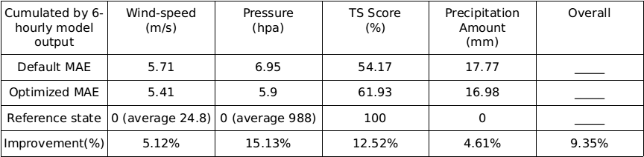

*Table5. Domain settings for for verification cases*

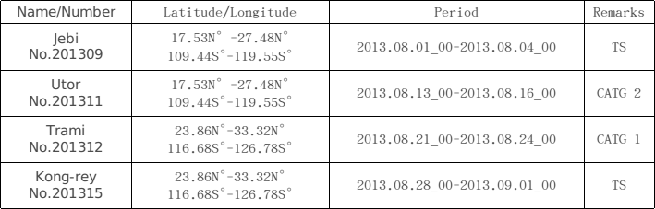

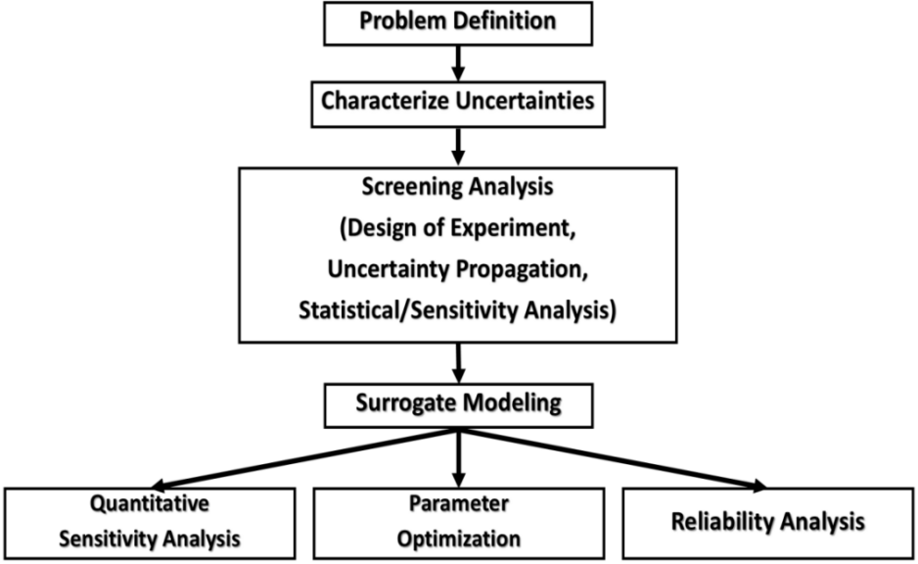

*Fig1. Key steps of UQ included in UQ-PyL*

*(Cited from A GUI platform for uncertainty quantification of complex dynamical models, EMS, Chen Wang and Qingyun Duan)*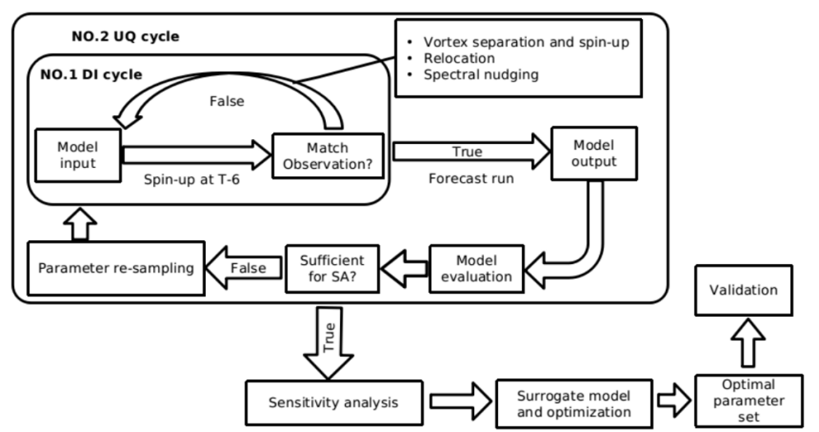

Fig2. Sketch of routine integrating DI&UQ

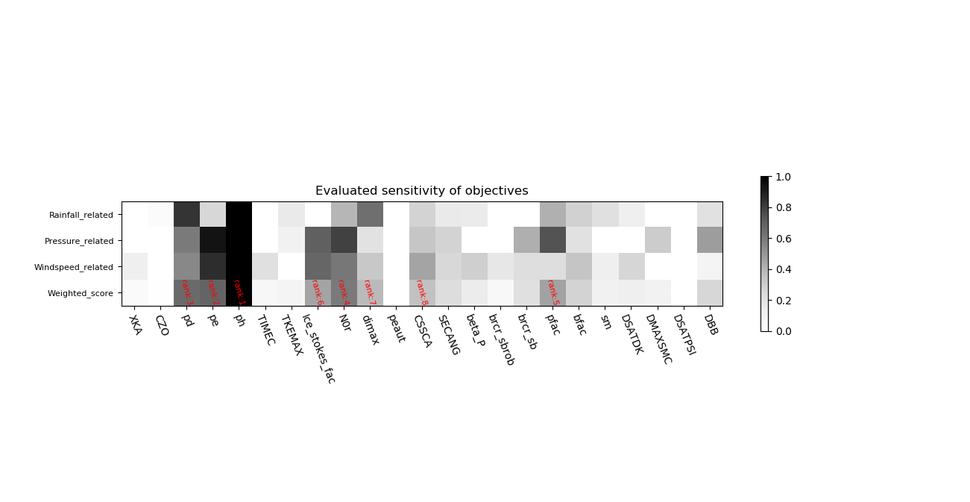

*Fig3. Sensitivity result of 23 parameters*

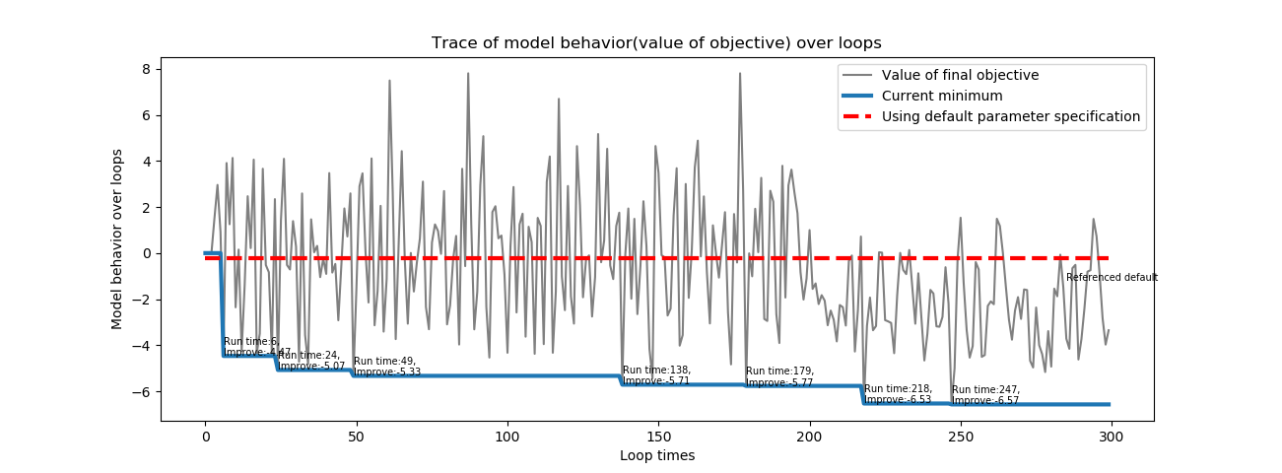*Fig4. Trace of model value over optimization*

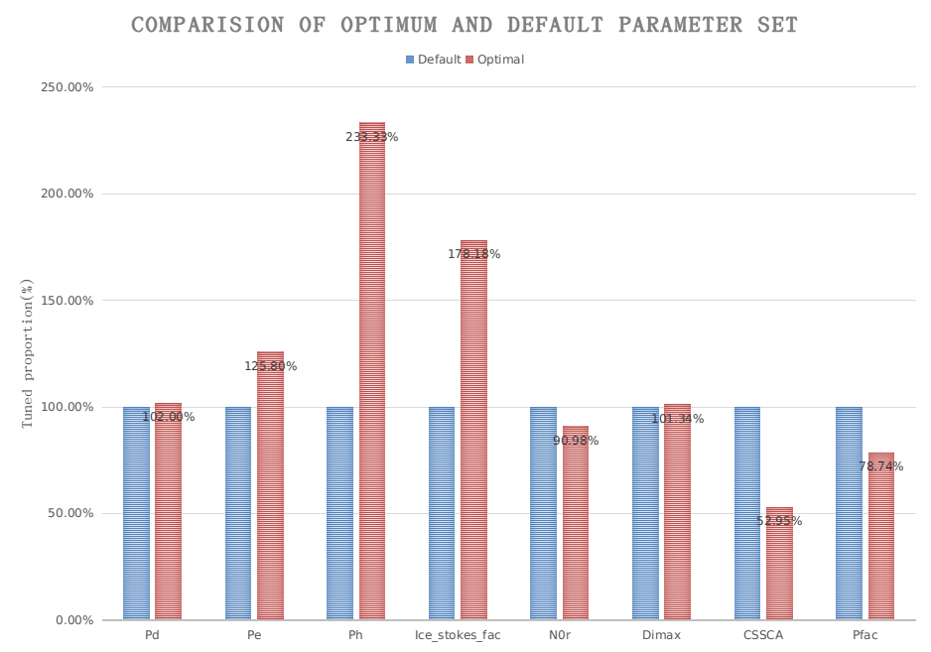

*Fig5. Trace of model value over optimization*

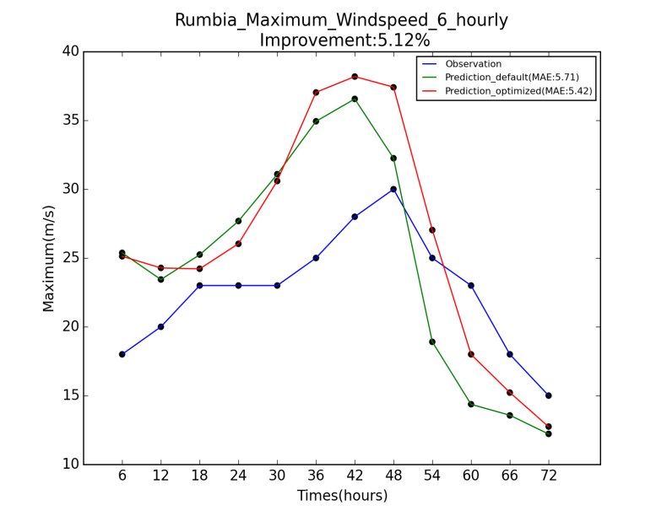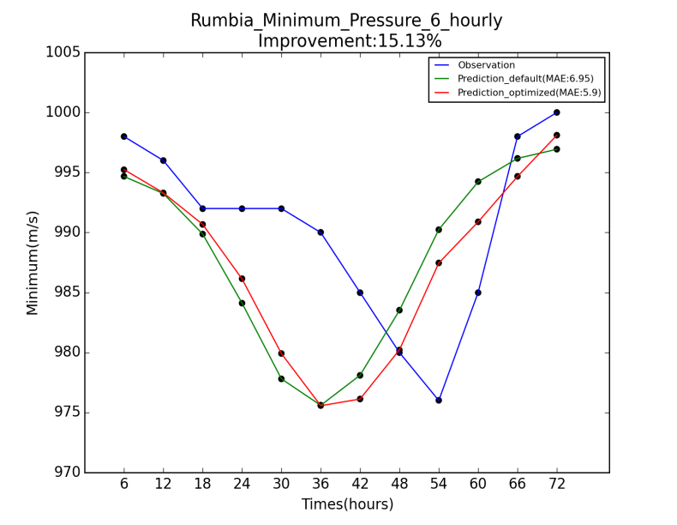

*Fig6. Comparison of forecast of maximum wind speed (left) and center pressure (right) with default*

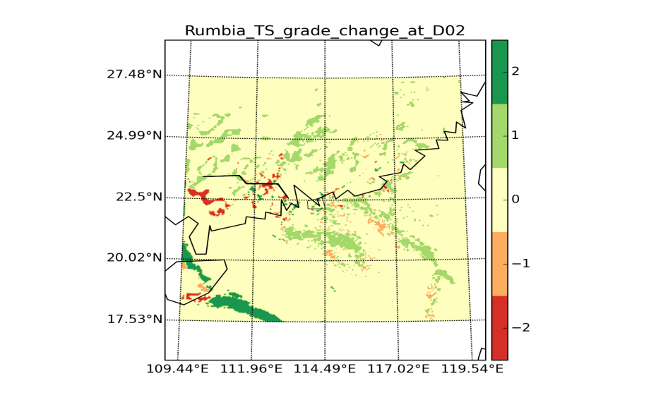

*Fig7. Alter of rainfall TS ranking*

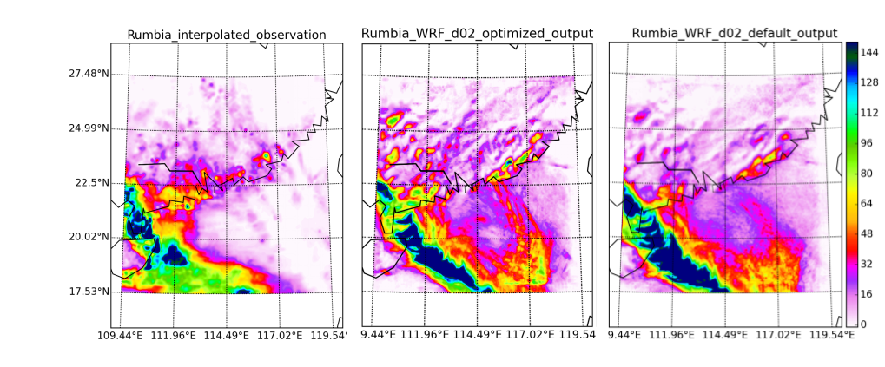

*Fig8. Three-day]s precipitation amount of interpolated observation (left), optimal model (middle), and default model (right)*

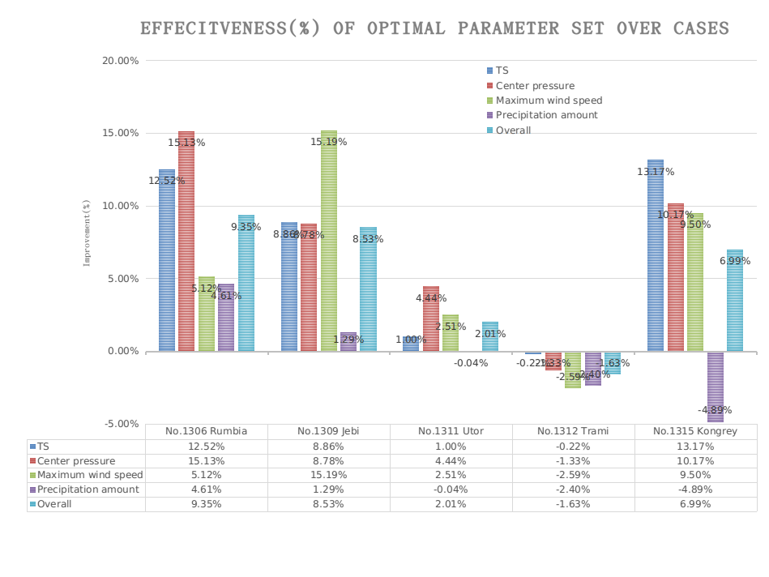

*Fig9. Validation results of four cases to optimal*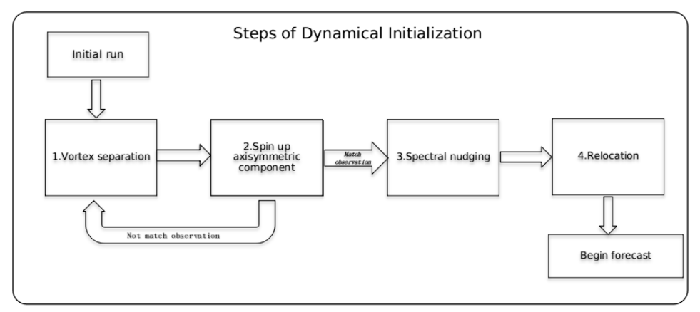

*Fig10. General view of major steps in DI*